Movie Booking App

Documents

Aggregations

Using Match

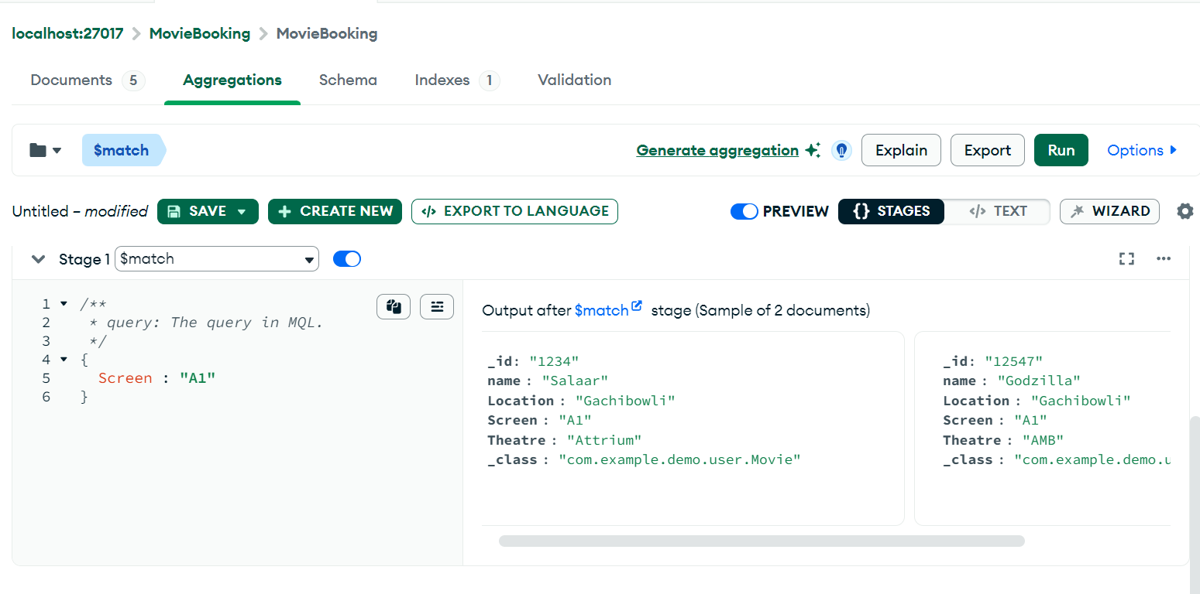

Using sort

Using match

Pipeline

Done By : Hemasree & Nagaraju